Assignment- 12

1) Write a query that selects all customers whose ratings are equal to or greater than ANY of Serres.
Ans:-

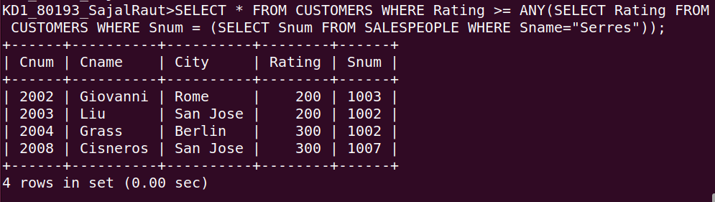
2) Write a query using ANY or ALL that will find all salespeople who have no customers located in their city.
Ans:-
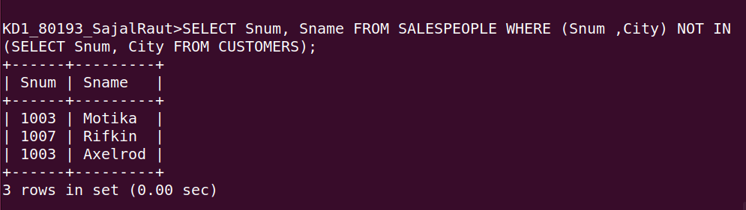

3) Write a query that selects all orders for amounts greater than any for the customers in London.
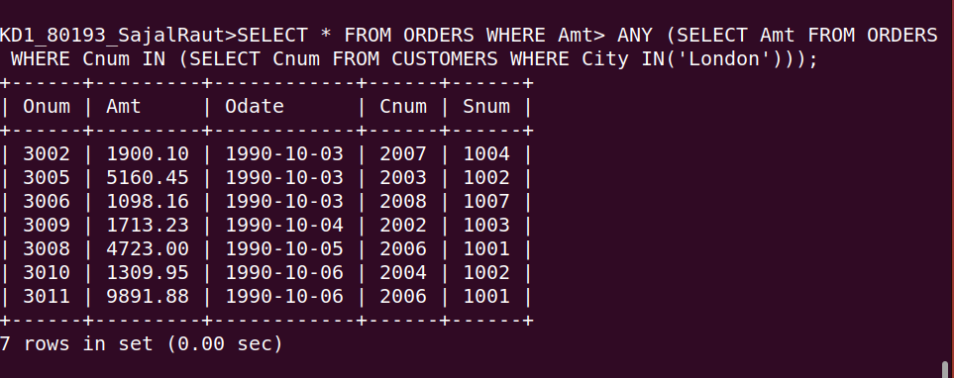
Ans:-
4) Write the above query using MIN or MAX.
Ans:-

